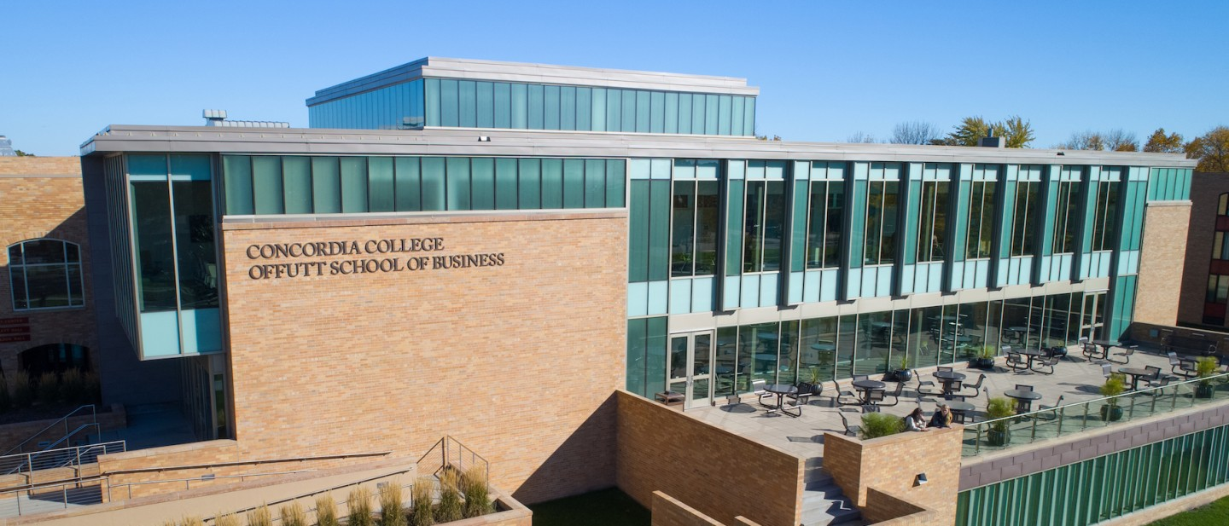

Wilson’s Ice

**CSC 310 – Fall 2020**

Course Name

**Creative Team Name – The Other Guys**

**Team Name**

**Team Member 1 – Bret   
Team Member 2 – Justin  
Team Member 3 - Oliver  
Team Member 4**

**Team Members**

The store is called “Wilsons Ice.” It will sell items from necklaces, watches, rings etc. The website will be inviting and visually appealing to try and get clients/customers to shop from us and also potentially invest in us. Our products sold from this website are for all people who are trying to get affordable modern-day jewelry that want to look “hip” but still maintain the high quality that more expensive jewelry have? This matters because it is very hard to find jewelry that is cheap, modern, and high quality, and we aim to hit all three of those criteria’s. The problem of not being able to find affordable, modern and high-quality jewelry by creating “Wilson’s Ice.”

**Synopsis**

The purpose of this project is to design and create an online store that can take advantage of the growing online market by selling affordable jewelry that is also high quality. Our store solves the problem of finding high quality jewelry at a lower cost. This project is important because there are not a lot of easy locations to find cheaper and high-quality jewelry. People who wear jewelry and are looking for an affordable way to get their jewelry would be the people that primarily benefit from this website store, but also all people who are looking for jewelry can benefit from this store.

**Purpose**

Executive Summary

# Background

Affordability and Quality are two of the biggest factors when searching for jewelry. A lot of people will assume that the cost of the item they are buying is associated with the quality. Our first problem will be conveying that our products are high quality even with the low price. This will be done by creating a visually appealing website that shows the high quality and modern theme jewelry we are selling. If our website cannot convey this message, we will not be able to sell many products. Historically, there have been a lot of jewelry stores on the internet that shares the similar goal we have of selling affordable high-quality items. The differences are we plan on selling all kinds of jewelry rather than specifically one singular item. Another problem we have to address is how we plan on getting traffic to our online store with there already being so many online jewelry stores. We will have to convince our customers that we are unique. This would benefit us and our audience because they would get affordable and high-quality jewelry and our business would be doing well.

**Problem**

# Project Plan

List each milestone and briefly describe what you intend to deliver and/or present; what work will you perform for each milestone?

Milestone 1: Contract: Group name and signing our lives away

Milestone 2: Outline: Come up with an idea for what we want to do and the basics to why and how to do it.

Milestone 3: Design: Draw out how we want the website to actually look and function.

Milestone 4: Template: Html template for what we want to be on the actual website.

Milestone 5: Halfway Presentation: Powerpoint for what we have done and a demo.

Milestone 6: Finishing Plan: Discuss how we are going to wrap the project up and create a spreadsheet to lay it out.

Milestone 7: Column/Update: IEEE 2-column and how we are coming along and wrapping up the project.

Milestone 8: Final Presentation: Present and make money.

**Milestone Summary**

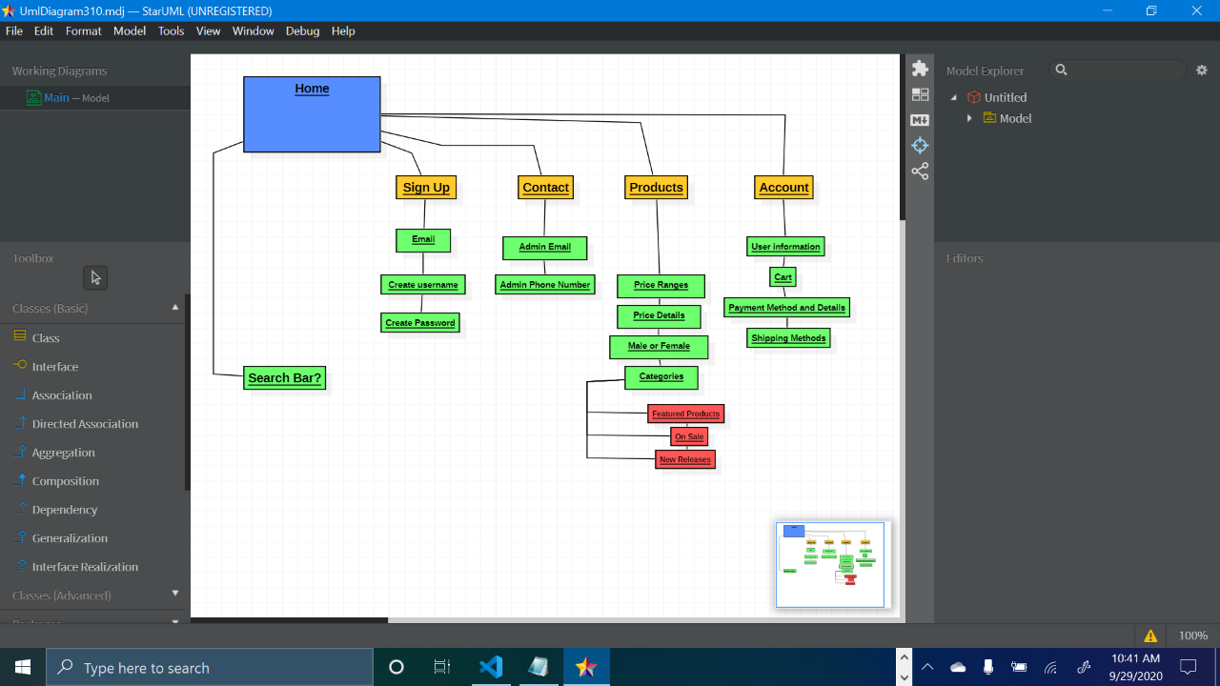

Provide detailed milestone information, including milestone roles and who worked on what tasks.

Milestone 1: Bret was the team lead and we met and decided who will be in charge of what milestones. We also discussed what it would look like to be the leader of the milestone, how we plan on communicating, and different plans how we could all work together and make sure we are all doing our fair share of work. E

Milestone 2: Justin was Team lead and took the initiative when making the diagram and writing our purpose and synopsis. Olivier and Bret worked on the remaining material and updated milestone details.

Milestone 3: Olivier was the team lead for the design phase. We planned out a vision of how we wanted the site to look like and created a similar structure in html and added in other images to display how we wanted the site to work.

Milestone 4: Bret was the team lead for the project proposal as well as the lead developer, and he focused on the demo and presenting what we had accomplished so far. Olivier and Justin worked on the slideshow to present the work we had done and cleaned up the code used in the demo.

Milestone 5: Justin was the team lead for the work plan and focused on sharing a spreadsheet for the team and figuring out what we had left. Bret designed the spreadsheets and added custom milestones and milestone information, and Olivier figured out what dates we should set to finish each goal.

**Milestone Details**

# Site Map

|  |  |  |
| --- | --- | --- |
| Date | Name/URL | Note |
| 9/29 | [justinkringle@wilsonup.net](mailto:justinkringle@wilsonup.net)  oliverthechosen.wilson.net  [Jpringle@wilsonup.net](mailto:Jpringle@wilsonup.net) FTP  [oliverthegod@wilsonup.net](mailto:oliverthegod@wilsonup.net)  Website: wilsonup.net | Sub domains |
|  |  |  |